***PAAREES PERFUMES***

***DAVIDOFF***

***FOR UNISEX***

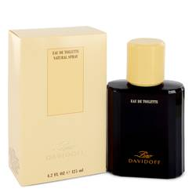

# *Zino Davidoff*

***Description:***

Zino Davidoff by Davidoff Cologne. This Zino Davidoff classic men's fragrance is masculine and impressive. Created in 1988, the combination of lavender, clary sage, bergamot, Brazilian Rosewood, and jasmine, is a timeless scent. For more than two decades, this Zino Davidoff fragrance has provided sophisticated men an earthy and attractive option for an evening out on the town. Described by many as timeless, this scent gives off hints of wood and spice along with earthly herbals creating a traditional masculine aroma.